Physical Fitness Test
Resources

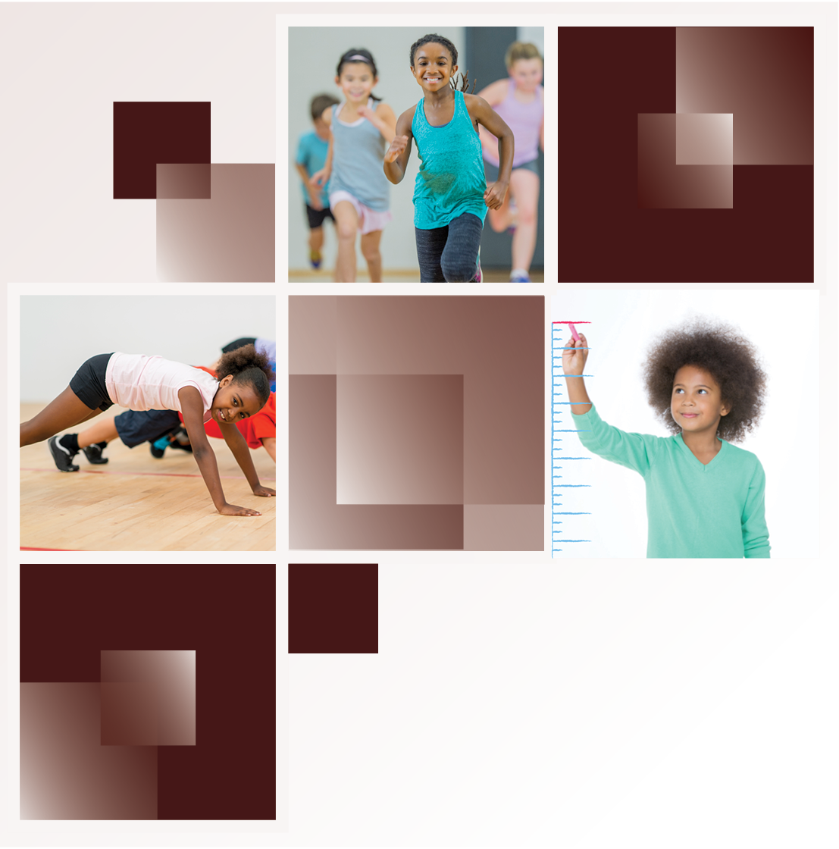
California Department of Education • December 2023

Resources

Physical Fitness Test Web Page
The California Department of Education (CDE) provides information about the Physical Fitness Test (PFT), which is required to be administered to students in grades five, seven, and nine, including links to web pages containing information regarding PFT administration and results.
Assessment Development and Administration Division
Email: pft@cde.ca.gov
Please visit the CDE PFT web page at https://www.cde.ca.gov/ta/tg/pf/.

PFT Coordinator Manual
This manual offers information and resources for PFT coordinators to prepare for, coordinate, and administer the PFT, including a sample data collection form and the student data file layout.
The PFT Coordinator Manual is available in the Resources for PFT Coordinators section of the PFT Resources web page at https://www.pftdata.org/resources.aspx.

PFT Reference Guide
This guide helps staff become familiar with the PFT. It describes the components, data collection requirements, equations and conversion tables used for estimating aerobic capacity and body composition, and performance standards, and gives suggestions for administering the different test options.
The PFT Resources Guide is available in the Resources for Test Administrators section of the PFT Resources web page at https://www.pftdata.org/resources.aspx.

PFT Training Resources
This web page includes training modules to assist PFT coordinators with submitting and correcting PFT data.
Please visit the PFT Modules, Videos, and Training web page at https://www.pftdata.org/training.aspx.

Prior-Year Physical Fitness Data
The CDE provides access to news releases and data reports for prior years (2003–15).
Please visit the CDE PFT: Prior Year Information web page at https://www.cde.ca.gov/ta/tg/pf/pftprioryrs.asp.

Educator Excellence and Equity Division Standards Implementation Support Office
The CDE provides information for improving student academic achievement of content standards by communicating policy and expectations and providing web resources to help school districts and schools develop quality physical education programs.
Educator Excellence and Equity Division
Email: plsmo@cde.ca.gov
Please visit the CDE Physical Education web page at https://www.cde.ca.gov/ci/pe/.

Physical Education Model Content Standards for California Public Schools
These standards represent the essential knowledge and skills that all students need to maintain a physically active and healthy lifestyle.
Please visit the CDE Content Standards web page at https://www.cde.ca.gov/be/st/ss/.

Physical Education Framework for California Public Schools
This framework describes a developmental, age-appropriate physical education program to provide students with the knowledge and ability needed to maintain an active and healthy lifestyle.
Please visit the CDE Physical Education Framework web page at https://www.cde.ca.gov/ci/pe/cf/.

